I. demand collection

Demand sources can come from market, user research, operation, testing, development, user feedback, product managers, etc. they will often ask you for demand in the normal work process, and will often interrupt your work to a certain extent. The correct way is to make clear the demand collection cycle, which can be a half month or a month for a summary of demand collection.



The normal process is to collect periodically, but there is a situation in which the business side never raises the demand. At this time, you need to take the initiative to talk with the business side to understand the business side's planning and participate in the business planning of the other side, which will make you have a higher understanding of the whole large product, and then dig more potential demand.

II. Demand sorting

After receiving the suggestions from the business side, we need to conduct a preliminary sorting, remove some invalid requirements, and record them into the requirements pool. How to eliminate invalid requirements: the demander will only tell you a solution. You need to ask the demander why, to understand the real requirements behind, to find out whether the existing solution has been solved or to save it in a better way online or offline. If you can, you don't need to put it in the demand pool.

Demand pool

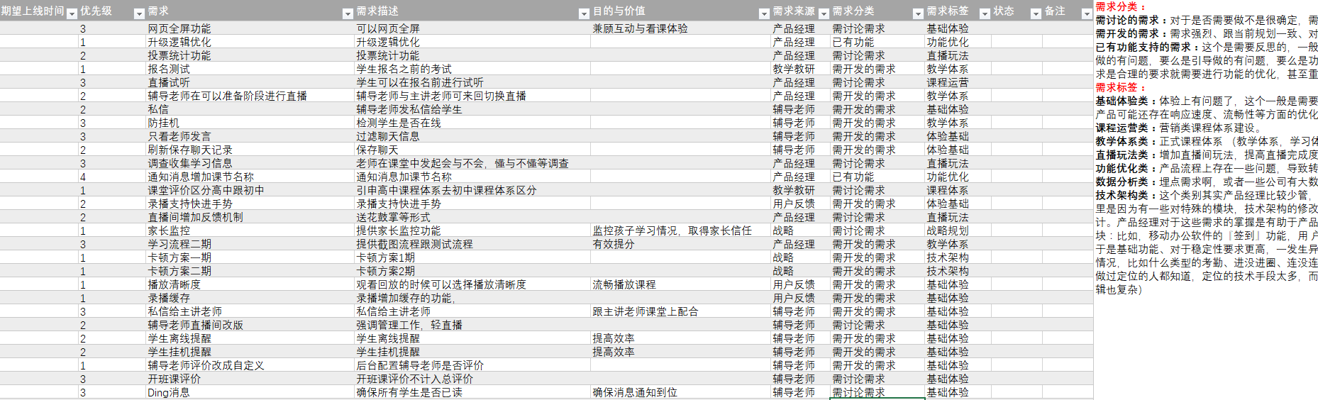

After filtering the invalid requirements, record the remaining requirements into the requirements management tool (the management tool can be various online tools or excel, which I prefer personally). Requirements need to record information including requirements, requirements description, purpose and value, requirements source, requirements classification and requirements label. Requirements are classified into requirements to be discussed and functions to be developed. The requirements to be discussed are not clear whether they need to be done and how to do them. Such requirements can be discussed with other product colleagues or with business parties to reach a conclusion. Requirements to be developed: requirements that are clear and can be developed. Requirement label: divide several business domains according to product planning, each of which has clear objectives, and then divide these requirements into business domains. One advantage of this is that it classifies the scattered requirements and has a general goal, rather than a single point of demand. Take online education front-end business as an example, it can be divided into the following:

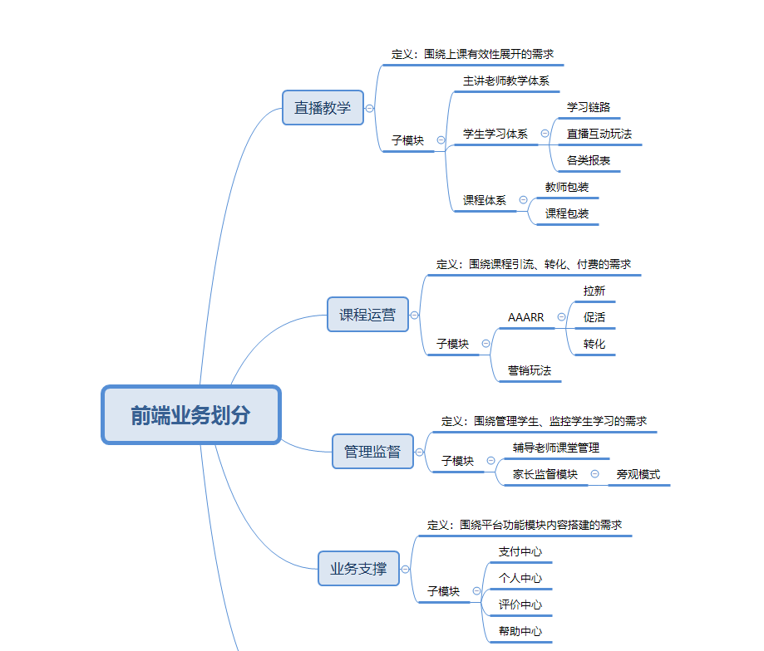

Business domain

III. demand priority

The demand scheduling in actual work may be based on the product's own feeling, which is very unscientific. In the Internet industry, a popular way is to use Kano model to prioritize.

Kano Model

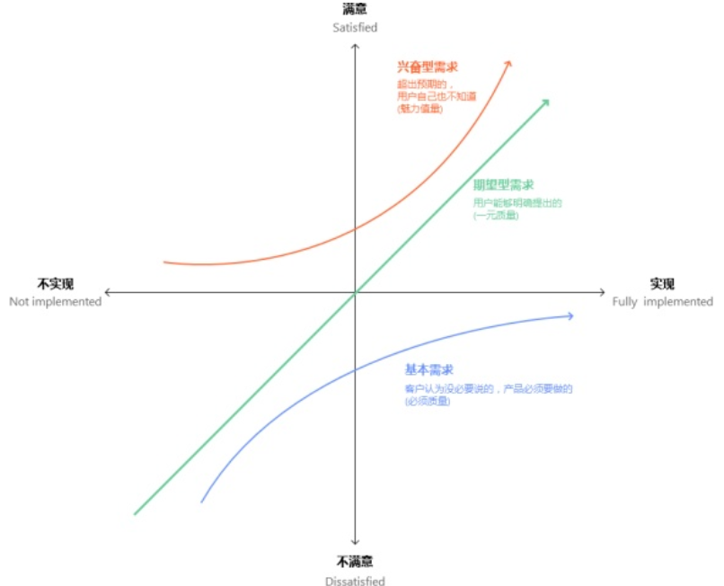

Demand is divided into exciting demand, expectation demand and basic demand. Priority: basic needs > expected needs > exciting needs. There are many introductions about Kano Model on the Internet. In Zhihu, an article by Ma dale is for your reference: Kano Kano model function priority ranking model.

Specific scheduling: the personal approach is to meet the needs with high priority, but it is also necessary to insert some lower priority needs in the middle, otherwise the excitability needs may never be ranked.